**Creating an Amazon Virtual Private Cloud (VPC)**

After completing this lab, you should be able to do the following:

* Deploy a VPC.
* Create a public subnet.
* Create a private subnet.
* Create an internet gateway and attach it to the VPC.
* Create an application server to test the VPC.

**Task 1: Creating a VPC**

A VPC is a virtual network that is dedicated to your Amazon Web Services (AWS) account. It is logically isolated from other virtual networks in the AWS Cloud. You can launch AWS resources, such as Amazon Elastic Compute Cloud (Amazon EC2) instances, into the VPC. You can configure the VPC by modifying its IP address range and create subnets. You can also configure route tables, network gateways, and security settings.

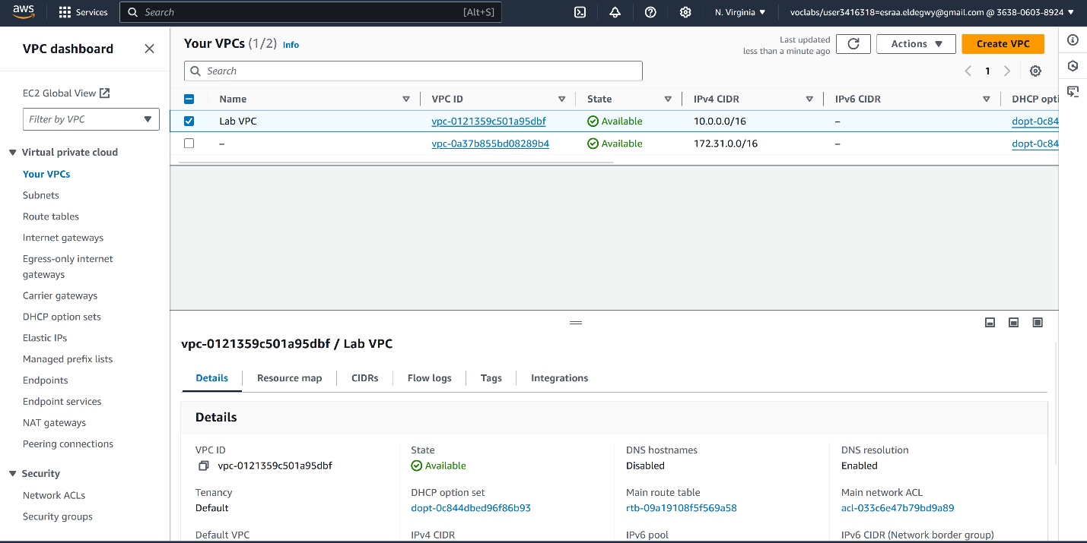

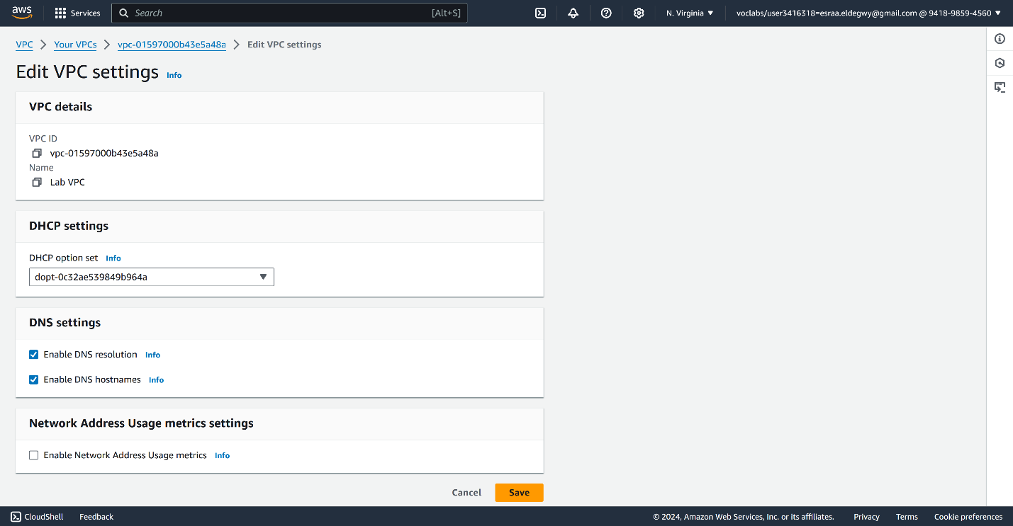

**Task 2: Creating subnets**

A subnet is a subrange of IP addresses in the VPC. AWS resources can be launched into a specified subnet. Use a public subnet for resources that must be connected to the internet, and use a private subnet for resources that must remain isolated from the internet.

In this task, you create a public subnet and a private subnet:

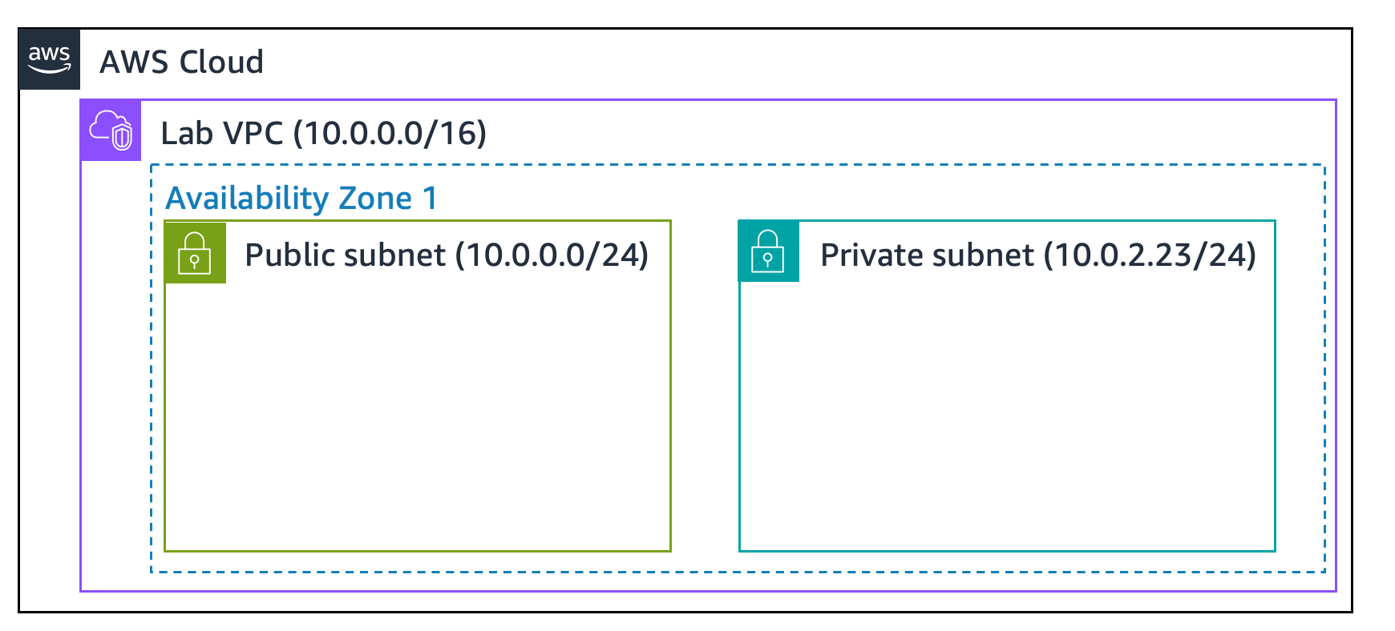

**Task 2.1: Creating a public subnet**

**Task 2.2: Creating a private subnet**

Your VPC now has two subnets. However, the public subnet is totally isolated and cannot communicate with resources outside the VPC. Next, you configure the public subnet to connect to the internet through an internet gateway.

**Task 3: Creating an internet gateway**

An *internet gateway* is a horizontally scaled, redundant, and highly available VPC component. It allows communication between the instances in a VPC and the internet. It imposes no availability risks or bandwidth constraints on network traffic.

An internet gateway serves two purposes:

* To provide a target in route tables that connects to the internet
* To perform network address translation (NAT) for instances that were assigned public IPv4 addresses

**Task 4: Configuring route tables**

A *route table* contains a set of rules, called *routes*, that are used to determine where network traffic is directed. Each subnet in a VPC must be associated with a route table because the table controls the routing for the subnet. A subnet can be associated with only one route table at a time, but you can associate multiple subnets with the same route table.

To use an internet gateway, a subnet's route table must contain a route that directs internet-bound traffic to the internet gateway. If a subnet is associated with a route table that has a route to an internet gateway, it is known as a public subnet.

In this task, you do the following:

* Create a public route table for internet-bound traffic.
* Add a route to the route table to direct internet-bound traffic to the internet gateway.
* Associate the public subnet with the new route table.

**Task 5: Creating a security group for the application server**

* A *security group* acts as a virtual firewall for instances to control inbound and outbound traffic. Security groups operate at the level of the elastic network interface for the instance. Security groups do not operate at the subnet level. Thus, each instance can have its own firewall that controls traffic. If you do not specify a particular security group at launch time, the instance is automatically assigned to the default security group for the VPC.
* In this task, you create a security group that gives users the ability to access your application server through HTTP.

**Task 6: Launching an application server in the public subnet**

To test that your VPC is correctly configured, you now launch an EC2 instance into the public subnet. You also confirm that you can access the EC2 instance from the internet.

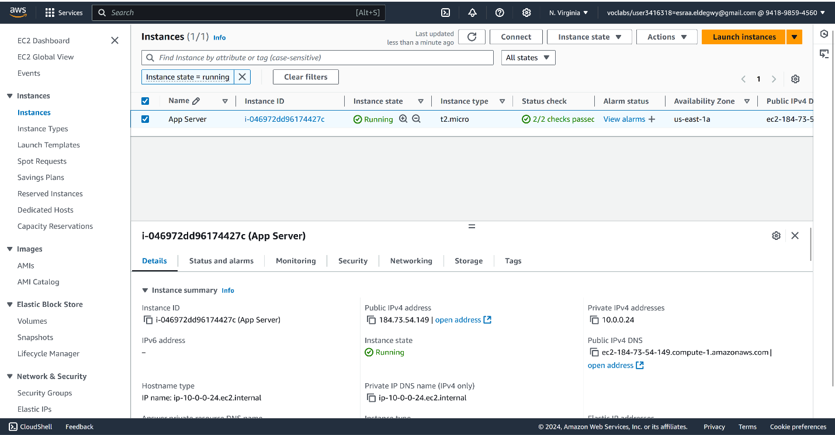

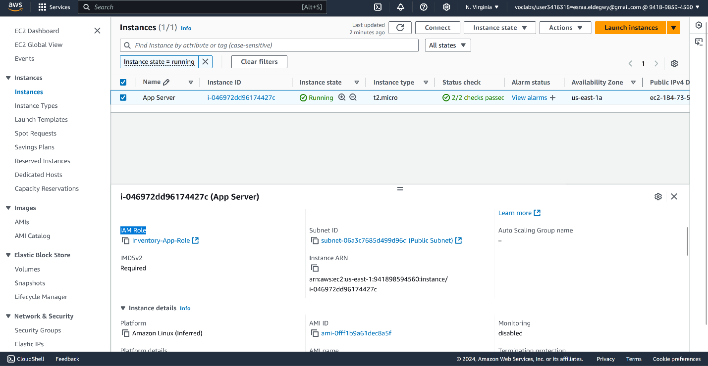

From the **Details** tab, copy the **Public IPv4 DNS** value.

Open a new web browser tab, and enter this public IPv4 DNS value.